Insecure Data Storage Part – 3

Open the DIVA application on the android emulator and select the 5th lab – Insecure Data Storage Part 3

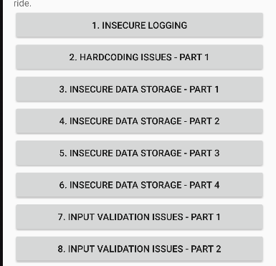

Open powershell in windows and login to adb shell

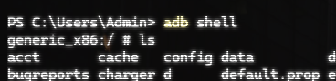

List the contents of the shell and switch to root mode using ‘su’ command.

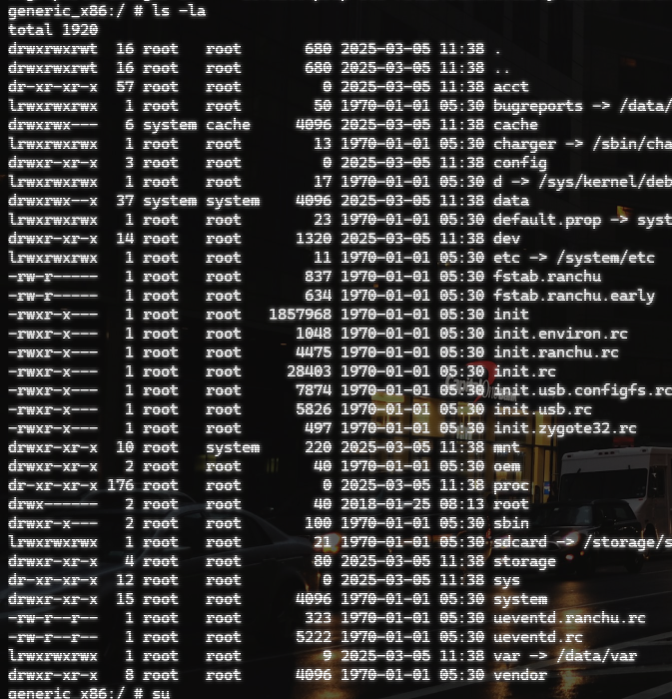

Go the data/data/ Jakhar.aseem.diva path to look for the credentials that we will enter in the emulator

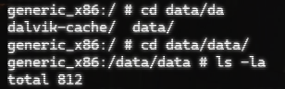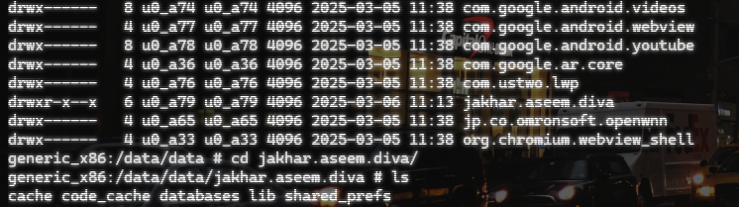

Enter credentials in the emulator

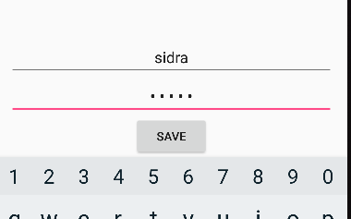

We see that we now have another file in the directory we accessed before, we can read this using ‘cat’ command and see the credentials we typed before, hence, exploiting insecure data storage vulnerability.

